**Building a tall Crush Grind® Pepper Mill**

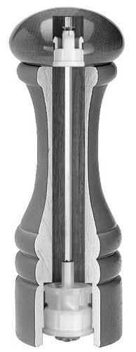**Supplies needed:**

* 10” Crush Grind Pepper Mill Mechanism (see notes for details)
* 3” x 3” x 12” hardwood non-toxic blank

*Minimum width is 2.5” x 2.5”*

*Shorter Grinders will require shorter blanks, figure 2” for tenons and scrap (e.g. a 6” overall grinder (top+bottom) will require 8” of wood)*

* Forstner drill bits: **15/16”, 1 – 1/16”, 1 3/8”, 1 – 9/16”, 1 – ¾”**
* (2) 3” x 3” x 3” scrap wood for jam chucks

**Prepare blanks**

* Mount 3” x 3” x 12” blank between centers.
* Rough Turn to round.
* Add check tenons 1, 2, & 3 as shown below.
* Part into Mill Head and Mill Body as indicated.
  + Mill body cannot exceed 9 3/8” in length.
  + Mill Head must be at least 1 ¾” long.
  + Finish parting Head from body using a saw with lathe off



9 3/8”

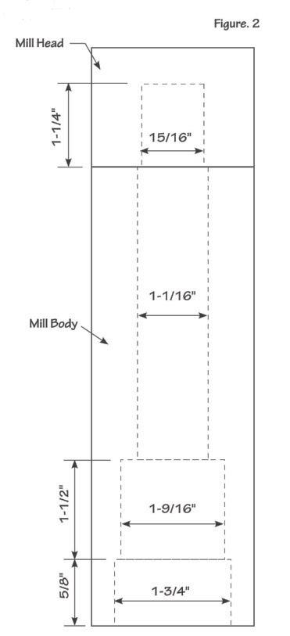**Drill blanks**

1. ***Mount*** the Mill Body in your chuck ***using tenon #2*** and drill
   1. **1 1/16” hole half way** through the remaining body depth.
   2. ***Reverse*** the Mill Body into ***tenon #3*** and complete the **1 1/16” hole** through the body.
   3. Drill a concentric **1 3/8” hole ¼” deep** as a mortise for the tenon to be shaped on the Mill Head.
2. ***Reverse*** the Mill Body in your chuck ***using tenon #2*** and drill 2 concentric holes in the body
   1. 1 ¾” hole 5/8” deep.
   2. 1 9/16” hole an additional 1 ½” deep.
3. Using the following drawing mount the *Mill Head* in your chuck and **drill 15/16” hole in the Mill Head 1 ¼”** deep; set it aside.

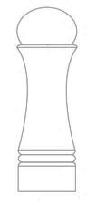**Approach A – When Body and Head aren’t one contiguous curve.**

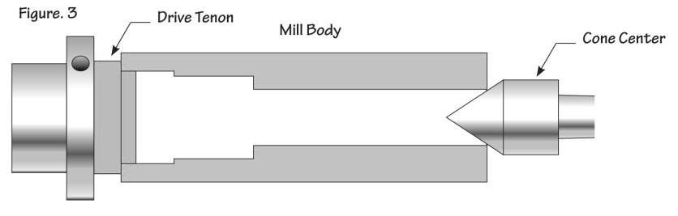**Turn a Mill Body shape**

* Mount a waste block in the chuck.
* Turn a tenon 1 ¾” diameter and ¾” long to tightly fit into the base of the Mill Body,
* Mount the body between centers with a live center supporting the opposite end.
* Turn a pleasing shape.
* Sand and finish.

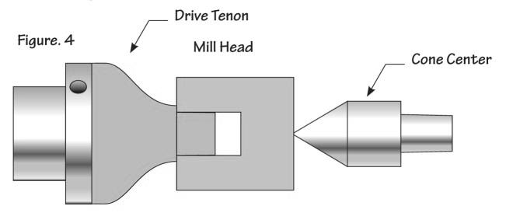**Turn a Mill Head shape**

* Reusing the initial waste block, turn a new tenon 15/16” diameter to tightly fit into the Mill Head.
* Mount the Mill Head and support with the tailstock live center.
* Turn a tenon **1 3/8” wide and no longer than ¼” deep** at bottom of Mill Head (nearest waste block). It must fit into the **1 3/8” Mortise** turned into the top of the Mill Body
* Turn and matching shape.
* Sand and finish.

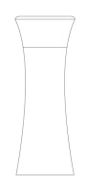

**Approach B – When Body and Head are a continuous curve.**

**Turn a tenon on the Mill Head**

Using a waste block, turn a new tenon 15/16” diameter to tightly fit into the Mill Head.

* Mount the Mill Head and support with the tailstock live center.
* Turn a tenon **1 3/8” wide and no longer than ¼” deep** at bottom of Mill Head (nearest waste block). It must fit into the **1 3/8” Mortise** turned into the top of the Mill Body

**Turn a Mill Body shape**

* Mount a 2nd waste block in the chuck.
* Turn a tenon 1 ¾” diameter and ¾” long to tightly fit into the base of the Mill Body
* Mount the Mill Body on the jamb chuck, the Mill Head on the Mill Body (using the 1 3/8” Mortise & Tenon) and support the Mill Head with a live center on the opposite end.
* Turn a pleasing shape.
* Sand and finish.

**Assembly**

* Prepare the Crush Grind ® mechanism for insertion by removing the protruding tabs on both the Mill Head stopper and the Mill Body mechanism.
* Mix a small amount of 5 minute epoxy thoroughly
  + Coat the inside of the Mill Head and insert the Mill Head stopper.
  + Coat the inside of the mill base 1 9/16” area only and insert the Crush Grind ® mechanism.
* Set both section aside to dry thoroughly 15-30 minutes.
* Assembly the Mill Head onto the Mill Body.

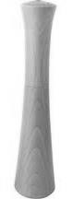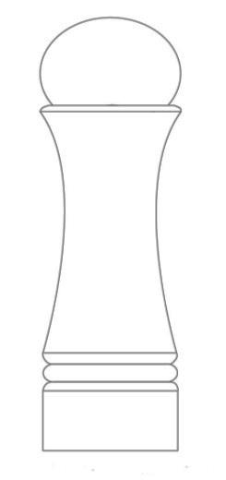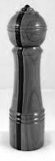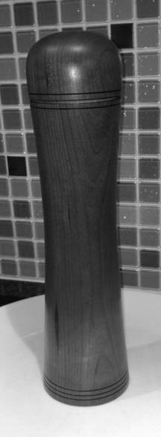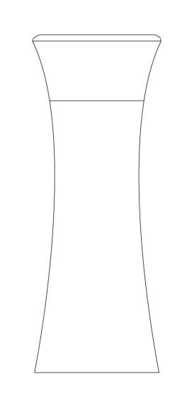

**Notes:**

* Tenons – be sure the tenon is over 2” in diameter as we will drill a 1 ¾” hole into the Mill Body base. There needs to be at least 1/8” wall remaining after shaping the base and turning away the tenon
* Assembly – I dry fit the components then remove them during the finishing steps. Re-assembly can be done with or without the epoxy depending on the tightness of your fit.
* Design – A different color wood may be used for the Mill Head. It can be turned exactly like the instruction above. If a salt mill is also created consider a dark Mill Head for pepper and a light Mill Head for salt.
* Design – If highly figured wood is used do not create a complicated shape or embellishment as the wood itself is decorative.
* Design – Consider the user’s hand when determining the size and shape of the Mill Head. The hand will grasp the mill over the top and must comfortably fit.

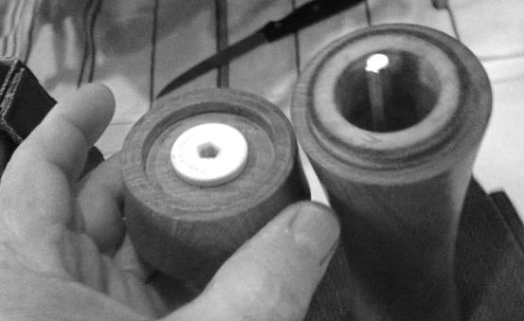

* Design – Expect to have to trim the aluminum pepper mill shaft for a custom fit. Be cautious, don’t take off too much at a time.

**10” Pepper Mill Crush Grind -- Ceramic**

|  |  |  |  |
| --- | --- | --- | --- |
| **Supplier** | **Web address** | **Part number** | **Listed price** |
| Craft Supplies | <http://www.woodturnerscatalog.com/> | 1012630001 | $16.35 |
| Packard Woodworks | <http://www.packardwoodworks.com> | 153201 | $15.95 |
| Rocker | <http://www.rockler.com/> | 32708 | $25.19 |
| Woodcraft | [www.woodcraft.com](http://www.woodcraft.com) | 146928 | $17.99 |

**Building a shaft less Crush Grind® Pepper Mill**

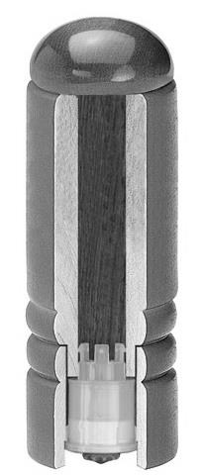

Supplies needed:

* 3” x 3” x 7” hardwood non-toxic blank (minimum length) for housing and body
* 3” x 3” x 3” contrasting hardwood blank for cap
* Forstner drill bits: 1 – 1/16”, 1 – 9/16”, 1 – ¾”
* 2 pieces, 3” x 3” x 3” scrap wood for jam chucks
* (1” O-ring)

Prepare blanks

* Mount 3” x 3” housing/body blank between centers.
* Rough Turn to round.
* Add check tenons 1, & 2 as shown below.
* Part into Mill Housing and Mill Body as indicated.
  + Mill Housing must be at least 3” length.
  + 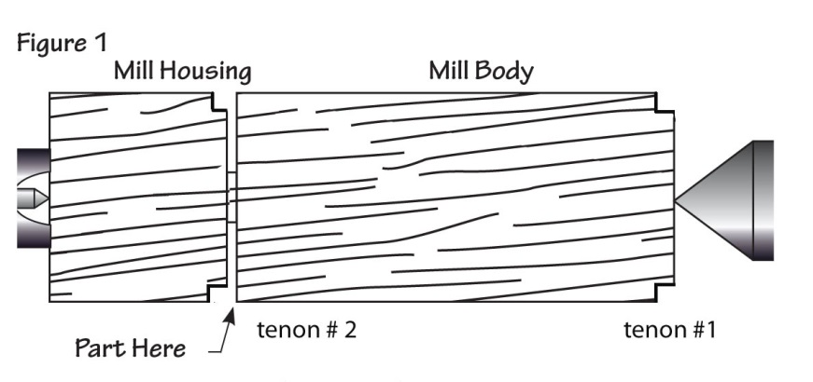Mill Body should be a minimum of 4” in length.

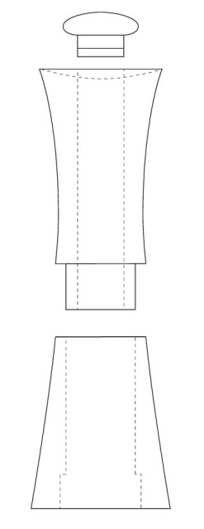

Drill blanks

* Using the following drawing mount the Mill Housing in your four-jaw scroll chuck and drill
  + 1 ¾” hole 3/4” deep.
  + 1 9/16” hole through the remaining housing.
* Mount the Mill Body into tenon #2 and drill a 1 1/16” hole through the body.

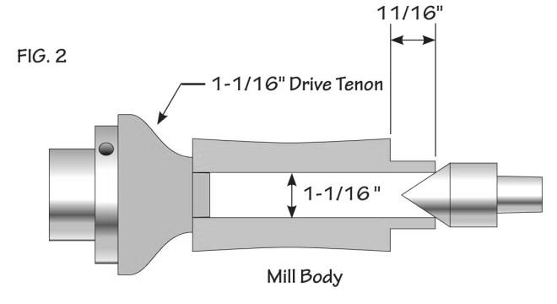Turning the Mill Body (fig. 2)

* Mount a waste block in the chuck.
* Turn a tenon 1 1/16” diameter and 1” long to tightly fit into the top of the Mill Body.
* Mount the Mill Body between centers with a live center supporting the opposite end.
* Turn a 1 9/16” tenon, 11/16” long that will fit snugly into the top of the Mill Base. Test this fit frequently.

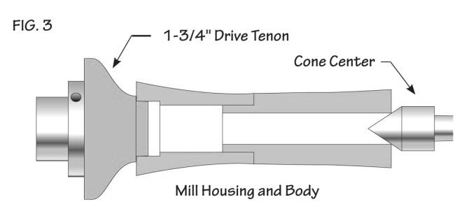

Turning the complete Mill (fig. 3)

* Mount a new waste block in the chuck.
* Turn a tenon 1 3/4” diameter to tightly fit into the bottom of the Mill Housing.
* Mount the Mill Housing and the Mill Body onto the jam chuck as shown with tails tock support and turn a pleasing exterior shape.
* Sand and finish.

Turning the Mill Cap

* Mount the Mill Cap blank into your chuck and turn round.
* Turn a 1 1/16” tenon ¾” long to fit tightly into the top of the Mill Body.
* Adding a O-ring seal
  + Loosen the fit of the above tenon by lightly sanding the surface.
  + Cut a “v” grouse 3/8” for the tip with the tip of a skew chisel of “V” tool.
  + Fit the O-ring onto the tenon and test its fit into the Mill Body.
  + The groove may be deepened to loosen the O-ring fit.
* Sand and finish.

Assembly

* Prepare the Crush Grind ® mechanism for insertion by removing the protruding tabs on Mill mechanism.
* Mix a small amount of 5 minute epoxy thoroughly
  + Coat the inside 1 9/16” area only of the Mill Housing and insert the Crush Grind ® mechanism.
* Set aside to dry thoroughly 15-30 minutes.
* Test fit the Mill Body onto the mechanism; it should fit snugly but allow for free rotation of the Mill Body.
* If the mechanism slips inside the Mill Body, lightly coat the lower inside of the Mill Body with 6-minute epoxy and reinsert the Mill Body onto the Mill Housing.