Inlaying a Celtic Knot in a Pen Blank

Keys to Inlaying a Celtic Knot
- Squared blanks -- For Celtic Knots, it is important that the blank be as square as possible and the top and bottom cut and squared as well.
- Dimensions -- For 7mm pens (e.g. Slimline, Designer/Euro etc.) blanks should be 5/8” x 5/8” x 5” – going larger is generally a waste of material.
- Blade Kerf--The material you inlay must match the kerf of the blade used to make the cut. Measure this in a scrap piece of wood before proceeding. Kerf for the Small Bandsaw in class will accommodate 2 standard sheets of veneer (or 2 pieces of 26 gauge metal).
- Inspect Blank -- Take a moment to inspect the blank and decide where you want to place the knot and how long it should be.
- Setup Jig – Use a simple jig that attaches to your Bandsaws Miter Gauge to accurately make the Inlay Cuts.
  - Setup a stop on the jig so that you can accurately register the blank for each cut. Set to ½” on the jig used in class.
  - Adjust the length of the knot by changing the angle of the Miter-gauge. Smaller Greater the angle the longer the knot will be. Jig in class is set to 37º which will give a knot about 1” long. Setting to 20 º will make the knot longer shorter, setting to 50 º will make it shorter longer.
- Inlay Cuts -- Celtic Knot requires 4 inlay cuts using the following sequence for each cut.
  - Place blank in jig and register against the stop.
  - Make cut – do not cut all the way through, leave about 1/16” uncut.
  - Glue inlays (wood glue for veneers, epoxy for metals) into cut. Trim inlay as required for accurate gluing.
  - Use gluing jig and a clamp to allow the glue to dry (about 25 minutes).
  - Trim inlay so blank is again square. Sharp chisel works well for veneers, Bandsaw for cutting aluminum veneer. (Be sure to support the aluminum against a ridged backing such as plywood for support.)
  - Rotate blank for next cut.
- Turning – The Celtic Knot inlay can be a bit delicate so a light touch is required. Tip: Use some thin CA glue to strengthen the knot and re-apply as you continue to turn the section down. Complete pen with a CA finish.

Notes:
Jig to accurately cut a Celtic Knot using a 37 º angle, attached to my bandsaw’s miter gauge. | 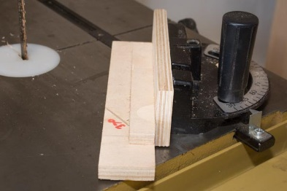
Blank ready for the 1st cut. Small clamp is acting as a stop to insure accurate registration. | 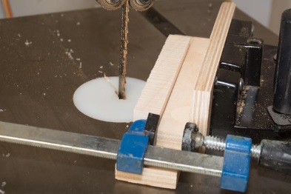
Don’t cut all the way through the blank, leave about 1/16” of wood to insure accurate gluing. | 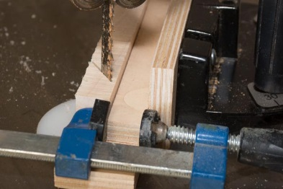
Best to have inlay pre-cut to match the width of the blank. In this example the inlay is 1 piece of veneer and 1 piece of 26 gauge aluminum. Glue-up will use a 5m epoxy. Previously measured to match the kerf of the Bandsaw blade. | 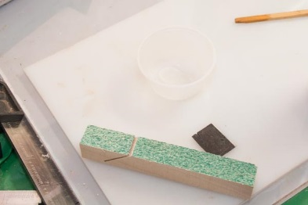
Gluing jig to insure an accurate glue-up. Jig is waxed to avoid gluing the blank to the jig. | 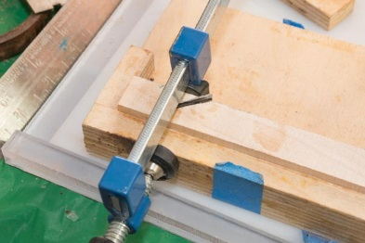
Trim inlay so blank is square. | 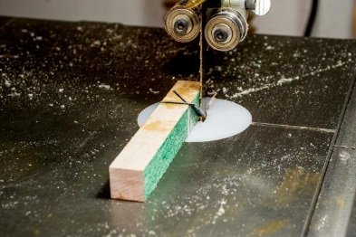
Ready for the next cut. | 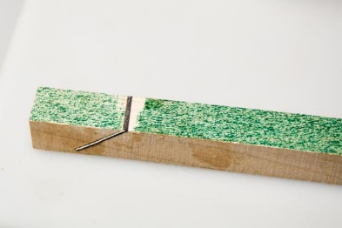
Rotate blank and repeat process – a total of 4 cuts are required. | 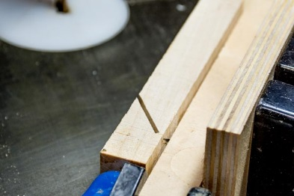
Completed Blank – Note, both sides of each X should line up on each side of the blank. The bottom of the Celtic Knot cuts should also line up and form a continuous line across each side of the blank. | 