How to Setup your Harbor Freight Pressure Pot

Overview:
This article is inspired by a post by Signguy on “How to setup your HF Pressure Pot without leaving Home”. I was really attracted by the cleanliness of the design and links to specific items on Amazon that I can easily order (I just love Amazon Prime!). It is not the cheapest approach but the hassle factor is significantly reduced. The original post was from Oct 2014 and some of the items were no longer available on Amazon, had long shipping times, or just weren’t available via Prime. In this article, I will provide updates to the parts I ordered, plus some better photographs to make it easier to visualize.

In addition to the pressure pot setup, I am going to include a section on making a clear acrylic vacuum lid—just perfect for stabilizing larger pieces. Once again, my goal was convenience and function rather than minimizing costs. Many thanks to MesquiteMan for all of his advice and help in designing this addition.

Pressure Pot:

Parts:
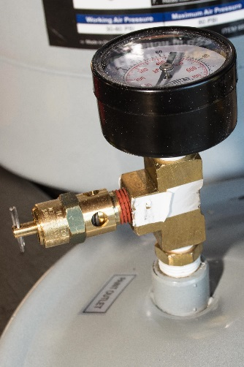
- Paint Side:
  - Gauge - Winters PEM Series Steel Dual Scale Economy Pressure Gauge, 0-100 psi/kpa, 2" Dial Display, +/-3-2-3% Accuracy, 1/4" NPT Center Back Mount
  - Tee Connector - Anderson Metals 56101 Brass Pipe Fitting, Barstock Tee, 1/4" x 1/4" x 1/4" NPT Female Pipe
  - Safety Valve - Control Devices ST Series Brass ASME Safety Valve, 60 psi Set Pressure, 1/4" Male NPT
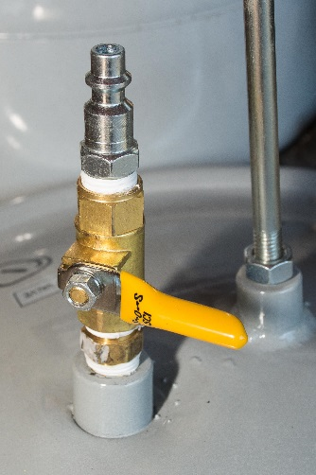
  - Male/Male Connector - Forney 75533 Brass Fitting, Reducer Adapter, 3/8-Inch Male NPT to 1/4-Inch Male NPT
- Air Side:
  - Male/Male connector - Anderson Metals 56122 Brass Pipe Fitting, Hex Nipple, 1/4" x 1/4" NPT Male Pipe
  - Ball Valve - Smith-Cooper International 8140 Series Brass Mini Ball Valve, Inline, Lever Handle, 1/4" NPT Female
  - Quick Connect - Dixon Valve DCP21 Steel Air Chief Industrial Interchange Air Fitting, Quick-Connect Plug, 1/4" Coupling x 1/4" NPT Male Thread, 37 CFM Flow Rating

Setup

Disassembly:
- Take everything supplied off the pressure pot lid. They are all low grade components so I felt much better not using any of them and instead using solid brass American made stuff.
- Contrary to popular belief - you can unscrew the inside paint tube and just get rid of it. Be prepared though - this stuff was put on TIGHT and with LOTS of pipe dope. You will need some big wrenches, strong arms and a bit of luck to strip them all off.
- The only thing I kept was the handle for the lid.
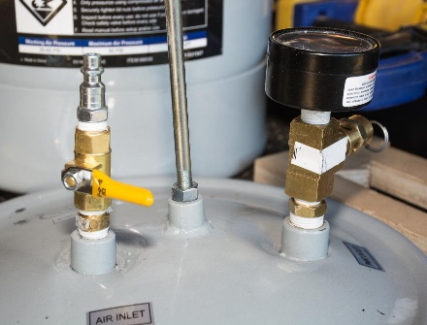

Assembly and Testing:
- Assembly wasn’t difficult—please consult the attached photos for details. I used standard Pipe Tape and a wrench. Make sure everything is nice and tight.
- Pressurize pot to low pressure (about 15-20 psi) and test for leaks using soapy water and a spray bottle. Resolve any issues and re-test at working pressure (50psi in my case).

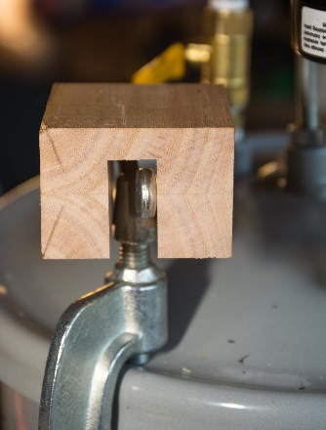
Tool to help Tighten Lid
- I made a small tool to help me tighten the clamps on the lid:
  - Wood Block -- 2 ½” (L) x 2” (W) x 2” (H)
  - Cut ½” dado in center.

Problems Encountered:
- Small leak from gasket under lid due to a slightly bump on the lip of the pot. Since pressure loss was about 10psi/hour, I have ignored this issue for now.
- Small leak in the weld on the underside of the lid where the paint outlet is attached. I was able to resolve this by putting some Gel CA on the underside of the pot where the leak was occurring, pressurizing to 15-20psi to drive the glue into the small crack and giving it about 30m to set. Kudos to GKetell for coming up with this approach—it has worked well so far.

Vacuum Lid:

Parts:
- Lid -- 12” x 12” x ¾” Acrylic
- Gauge – 2.5” Vacuum Gauge
- Other Fittings – Turntex Complete Chamber Plumbing Kit
- Gasket -- Buna-N Sheet Gasket, Black, 1/8" Thick, 12" × 12" (Pack of 1)

Special Tools:
- ¼” NPT Tap - Pipe Tap & Die Set 6 Pc
- 7/16” Drill bit

Assembly and Testing:
- Locate holes on acrylic blank for vacuum outlet and pressure gauge (Figure 4 – Acrylic Top)
4”
4”
6”
3”
3”
  - Draw diagonals and find center.
  - Locate holes 4” from center on the same diagonal (e.g. 8” from each other). This moves an area of weakness towards the lip of the chamber.
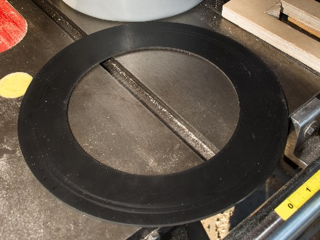
- Cut corners off the blank -- I cut off the corners of the Acrylic blank making sure I had plenty of overhang for the 10 5/8” lip of the pressure pot. I measured 3” up each corner and made a cut on the bandsaw (Figure 4 – Acrylic Top). This made it less likely I would bump into a corner as the pot was sitting on my workbench.
- Cut Gasket – Outer Dimensions of the Gasket is 11 ½”, Inner Dimensions 9 ½”. Decided to make the cuts on the lathe by:
  - Started with a 12”x12” piece of plywood mounted on center to a faceplate
  - Tape Buna-N gasket to plywood matching corners.
  - Brought tailstock up using cup-center
  - Cut outside diameter first then inside
- Drill and tap holes—Use 7/16” Drill bit and ¼” NPT Tap
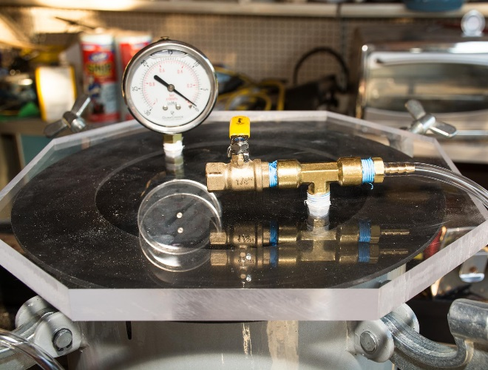
  - Drill holes in locations marked in Step-1.
  - Tap holes carefully making sure not to cross-thread them. Since this was the first time I tapped anything, I had a couple of practice runs to get the feel of it.
- Mount Gauge and Vacuum Outlet—Assembly wasn’t difficult. Please consult the attached photos for details. I used standard Pipe Tape and a wrench. Make sure everything is nice and tight.
- Test -- Hook quick release up to your vacuum pump
  - Turn on pump
  - Press down on lid (you need to do this to compress the gasket and the vacuum going)
  - Slowly close ball valve
  - Check pressure – I had no issues pulling 28 inHg.

