Brickwork Style Segmented Pen

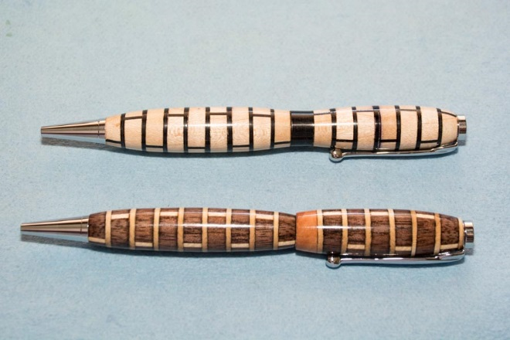

Key Points:
- Wooden-Segments - Use Straight-Grained wood that will contrast with the Veneer. Segments should be ¾” square and 3/16” thick with a double layer of Veneer in the center. See directions below.
- Veneer – Use a double layer of Veneer and cut ¾” square. See directions below.
- Wooden Band – Add a matching wooden band (3/4” square, 3/16” to 3/8” thick) and toss out the one that comes in the Slimline kit.
- Bottom Blank – Make the bottom blank 2 3/8” long which will improve the over-all look of the pen. Custom cut 7mm pen tubes to 2 3/8”.
- Prepare Blanks – See directions below for preparation details. Make sure the blanks have been flooded with Thin CA Glue and allowed to dry.
- Barrel Trimming – Take it slow and gentle. Don’t be aggressive in your cuts.
- Turn Pen – Turn the top and bottom portions of the pen using a Mandrel and Slimline bushings. Take it easy—don’t be aggressive. Remember this is a segmented pen and is relatively fragile. Add additional Thin CA glue as needed.
- Finish – Plan to use a CA Finish for the pen. The CA used in the glue-up and turning will not be visible after the Finish is applied.

Wood Segments:
Prepare Blank:  - Start with a ¾” thick board that is sanded on both sides.  - On Bandsaw, re-saw the board into (2) 3/8” thick pieces.  - Glue boards together:  - Flip boards so sanded side is to the middle  - Glue boards with 2 sheets of veneer between them.  - Clamp and let dry  - Cut into ¾” square lengths | 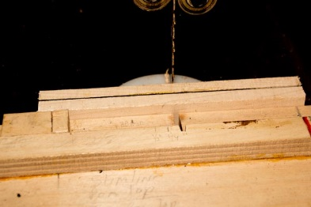
Cut and drill  - Cut into 3” lengths  - Drill a 7mm hole through blank making sure to clear the chips frequently. | 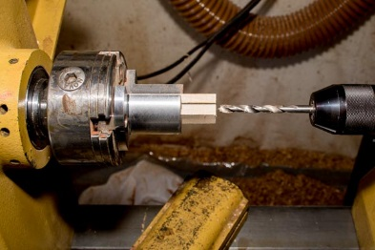
Cut Segments  - Use cutting jig on a Tablesaw with a zero-clearance insert.  - Segments should be about 3/16” wide  - Carefully cut segments using the hold down for safety. | 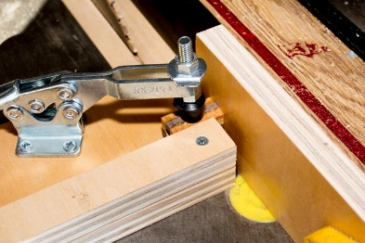
Lightly sand Wood-Segments  - Lightly sand wood-segments to insure they are flat. | 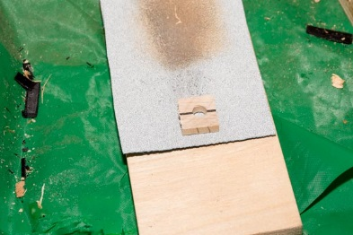
Drill and cut a band to be used instead of the Slimline Band. Tip: Use the same jig and approach as you used for cutting the wood-segments. Band should be of contrasting wood and can be anywhere from 3/16” to 3/8” thick depending on your design preference. | 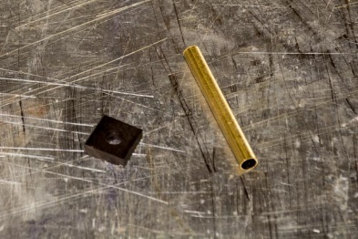

Veneer Segment Preparation:
Glue (2) 8”x10” sheets of Veneer together. Use a Veneer that will contrast with the wood on the pen blanks. | 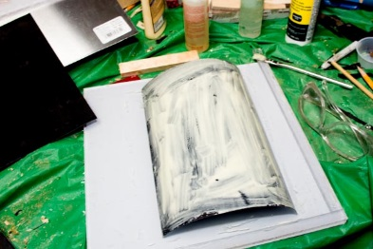
Use the jig to insure accurate registration between the sheets. Place another sheet of plastic on top, weight and allow to dry | 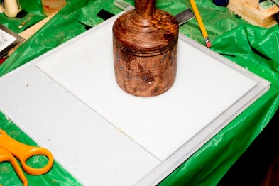
Cut Veneer into ¾” strips (to match width of segments) and jig. | 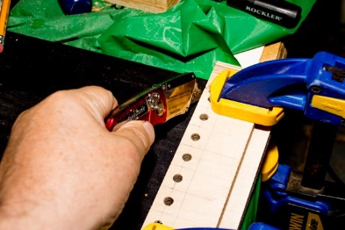
Bundle Strips together – Tip: Use 2 thin strips of wood (1/8” thick, ¾” wide) and bundle the strips between the wood strips and then tape that. | 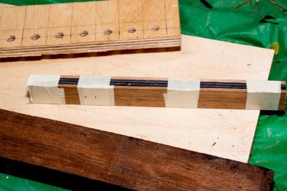
Use as many strips of veneer as needed to match the height of the jig (typically 6 veneer strips and 2 wood strips). | 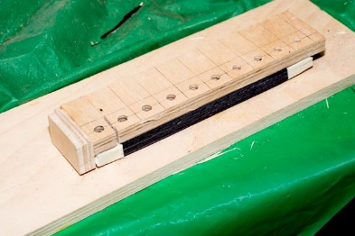
Carefully register the veneer strips in the jig and drill a 7mm hole through the wood strips and veneers. | 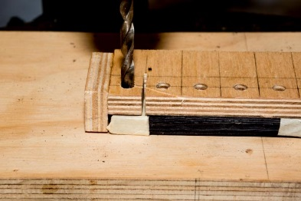
Move jig to the Bandsaw and cut out a square of veneers. Tip: Drill 1 square and then cut it on the bandsaw. Then register the veneer in the jig again and repeat the drilling and cutting process. | 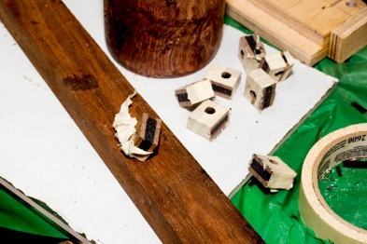
Bag Segments and Veneers  - 18 Wooden Segments  - 16 Veneer Segments | 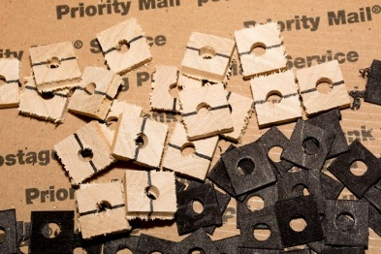

Glue-up the Pen Blank
Organize all of your materials:
- Nitrile Gloves
- Med-thick CA Glue
- Thin CA Glue
- 18 Wood-segments
- 16 Veneers
- 1 Wood Band
- 2” 7mm Pen Tube (for top of pen)
- 2 3/8” 7mm Pen Tube (for point of pen)
Glue-up the Pen Top Blank first (2” pen tube)  Use Med-thick CA Glue and glue the wooden band on the tube. | 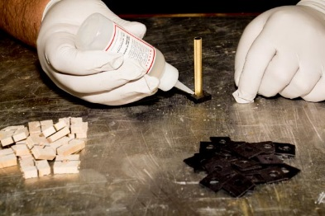
Add a wooden-segment and then drizzle some Thin CA to lock it to tube and blank below. | 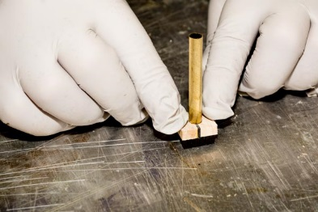
Add a layer of Veneer and then more Thin CA | 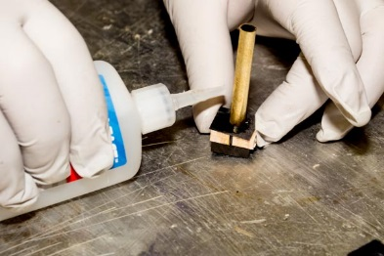
Next add another wooden-segment but rotate 90º and more Thin CA . | 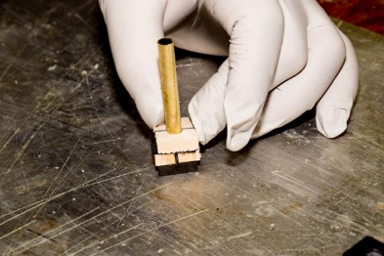
Continue adding layers of Veneer and Wooden-segments and gluing with Thin CA (rotating each wooden-segment 90^{o )} until tube is completely covered. | 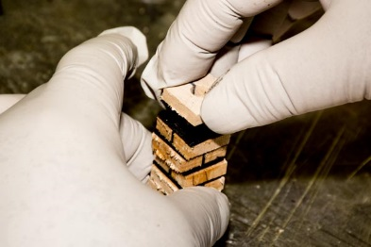
Flood the blank with Thin CA glue and then let dry | 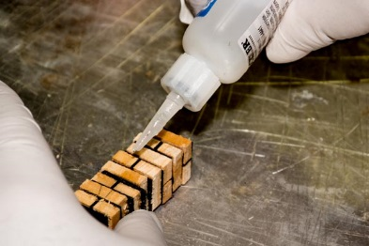
Glue-up the Pen Point Blank first (2 3/8” pen tube)  - Start with a Wooden-Segment and Med-Thick CA  - Add a Veneer and use Thin CA  - Add a Wooden-Segment and rotate 90º, use Thin CA  - Repeat Steps 2 & 3 until blank is completed  - Flood blank with Thin CA and then led dry | 