Woodturning 201

Turning Wood Bowls

  - Course number 874301

Mt. Diablo Adult Education
A division of the Mt. Diablo Unified School District
Serving Lifelong Education
One Santa Barbara Road, Pleasant Hill, CA 94523 (925) 937-1530

Rules of classroom conduct

- Always maintain a safe work environment for yourself and others
  - Wear a mask while in the classroom
  - Always wear safety glasses or face shields as required
  - Advise instructor of any safety concerns or issues

- Clean up at the end of each class
  - Your work area/lathe
  - The classroom floors and tables
  - Sharpening center
  - Replace all tools/accessories into the proper location

- Always sign in on arrival
  - Advise instructor if you plan on leaving early

- Be responsible for your own personal tools/equipment

Woodturning Safety Rules

1. Know Your Equipment and Yourself. Never operate a lathe or use a cutting tool, chuck or other accessory without first understanding its operation and limitations. Read and know the instruction manual of any lathe that you use. Never perform a procedure or technique that you are unclear about or uncomfortable with. If you are in doubt, stop and ask for instruction. Know your personal limitations.

2. Focus on Your Work. You may not operate a lathe if you have drunk alcohol or taken medication that carries an equipment operations warning. Don’t operate a lathe if you are tired or emotionally upset.

3. Police Your Environment. Keep your work area clean. Store tools safely. Don’t allow cords to run across circulation ways. Don’t start your lathe if people are in harm’s way. Ensure that there is adequate light and ventilation. If you are observing someone else, don’t place yourself in harm’s way.

4. Keep Yourself Catch Free. Long hair must be tied back. No clothing, gloves, jewelry or watches may be worn below the elbow. Necklaces and loose clothing that could be caught by spinning parts must not be worn.

5. Wear Safety Equipment. To operate a lathe or stand near an operating lathe, you must wear face/eye protection. Dust masks are highly recommended.

6. Secure the Wood. Ensure that the wood is securely held. Turn between centers whenever possible and always with imbalanced pieces. Use a slow speed when first roughing out a piece. Never use wood that is cracked or has other serious defects or significant protrusions.

7. Inspect Your Lathe. Inspect the lathe for damaged or missing parts before operating it. Before you start, check to ensure that the speed is appropriate, the drive belt is tight, all locking devices are secure and all chuck keys and adjusting wenches are removed. Always spin the wood at least one full turn before turning the lathe on - every time. Never leave a spinning lathe unattended.

8. Practice Safe Techniques. Keep your tools sharp. Don’t force a tool or use it for an unintended purpose. Reposition the tool rest frequently to keep it close to the work. Keep your balance and don’t overreach. Always turn the lathe off and allow it to come to a complete stop before adjusting the tool rest. Always keep your hands behind the plane of the tool rest. Always keep the tool firmly against the tool rest. Always hold the tool firmly with both hands.

When using a shear cut, rub the bevel. When using a scraping cut, always keep the angle between the wood and cutting edge at less than 90 degrees.

When finishing, always remove the tool rest. Use only paper towels, never woven fabric. On exterior surfaces, apply the towel to the underside of the piece with the wood spinning counterclockwise. On interior surfaces, apply the towel in the lower left-hand quadrant also with the wood spinning counterclockwise.

Observations on the Use of Woodturning Tools

Here are the few things that always seem to be beginner’s difficulties:

- Tight body
  - This means a lack of freedom of movement restricting the fluid motions with the tools causing poor shaping of the project and irregular surfaces due to poor tool control.
  - Rigid, tight muscles locking the tool tightly to the hand and fighting the wood/lathe combination
  - All body motions generally need to be expanded, enlarged, and used to enhance the cuts’ fluidity and ease.
- Working too fast
  - Forcing the tool through the wood rather than understanding how fast the wood wants to be cut with that tool and at that lathe speed.
  - Cutting the wood before planning the best approach to the cut.
  - Starting without an overall plan of what shape is to be achieved.
- Cutting with the wrong lathe speed
  - First projects are normally spindle projects on smaller billets of wood requiring greater RPM’s to allow for smooth cutting.
  - Bowl turning, starting with out-of-balance stock may require the speed to be reduced until the stock is more balanced. Then the speed can be increased to improve the cuts
  - Cutting projects with voids or discontinuous surfaces required an increase in lathe speed for more cutting control.
- Working with dull tools.
  - Everyone can recognize the improvement of the cut surface and the greater ease in cutting when a tool is sharpened but few recognize when to re-sharpen the tool.
  - Sharpening requires a light hand to “dress the edge” rather than “grinding the tool.”
- Not recognizing that you must “pay your dues.”
  - Doing it again to improve lathe/tool/body operation is called “practicing” which few are willing to do. I suggest make one, examine what could have been done differently – then do it again
  - Complex project are attempted in quality wood without doing a prototype – sometimes with disappointing results. Consider making a prototype in plain wood first.
  - Not making enough spindles

TOOL CONTROL

Dancing with Your Lathe
- Like dancing, woodturning is about making graceful body moves.
- Guide the tool through the wood using your whole body and not just your arms. Using your whole body gives you more stability and is less tiring.
- Spread your feet about shoulder width apart. Keep your elbows close to your side. Start a cut with your weight on one foot and gradually shift your weight to the other foot.
- If the cut is too long to easily keep your balance, make two separate cuts by stopping, repositioning your feet, and restarting the second cut. It will be necessary to use only your arms for some cuts but try to minimize these.

Role of the hands.
One hand holds the tool on the tool rest (keeping it from vibrating) and aids in moving the tool forward. The other hand does most of the work. It guides the tool and determines the depth and direction of the cut. Learn to turn reverse hands, there are some cuts that must be done right-handed or left handed.

Making an External Cut

Anchor. Place the gouge on the tool rest with the flute pointing upward at a 45° angle and in the direction of the cut. Lay your left hand on top of the gouge and contacting the tool rest. All three, gouge, tool rest and your hand, must all be in contact with each other.
Bevel. Using your right hand, move the tool handle until the heel of the bevel contacts the wood. This action will not cut but will tell you exactly where the wood is relative to the tool.
Cut. Using your right hand continue moving the tool handle until the bevel is parallel with the wood surface and the cutting edge engages the wood. The tool should be cutting between' 11 and 12 o'clock' as you look down on the tool. Slowly advance the tool with the left hand, remembering to steer the bevel with the right hand.

Cutting Feedback
Listen. The lathe, tool and wood all give you feedback on how well you are cutting. Learn to 'listen' to the following.
Shavings. If you are producing long shavings, you are shearing the fibers. Chips or sawdust means that you are scraping and will have a rougher surface.
Vibration. Vibration should be avoided. Excessive vibration may mean a loose piece of wood is ready to fly off the lathe. Vibration can also be caused by excessive lathe speed and the wood being out of round/imbalanced.
Sound. A rhythmic sound may indicate a knot, crack or other defect that should be inspected immediately. A good cut will 'sing'.

Direction of cuts

When making cuts we try to cut “downhill to the grain.” This is the direction in which the fibers being cut are more supported by the un-cut fibers below. The supported fibers cut more cleanly resulting in less tear out, smoother cuts and the final effect – less sanding.

In bowl turning “downhill” will be a function of how the blank is oriented on the lathe. Most side grain bowls appear as indicated in the illustration. In end grain bowls the downhill cut is from the center of rotation outward toward the rim – a difficult cut to make with a gouge. This direction generally requires a scraper.

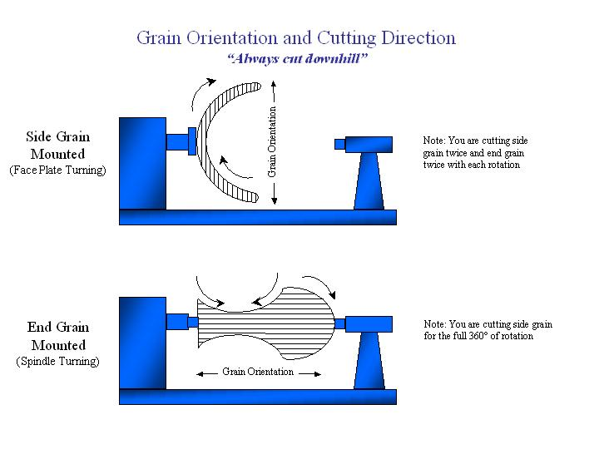
Basic Shapes - Bowls

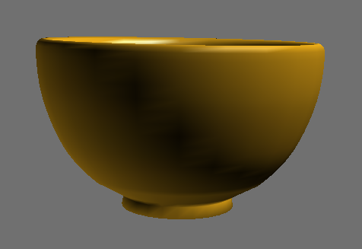
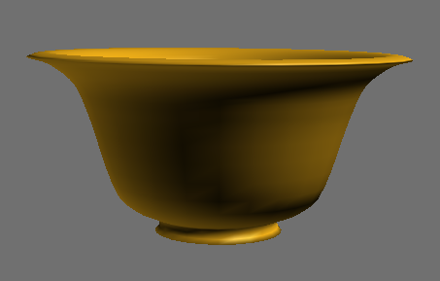

Continuous positive curve

Sung Dynasty ceramic bowl

Ogee curve

Kelly Dunn Norfolk Island Pine bowl

Mastering the Bowl Cut

The Rule of 45’s

Proper positioning of the body and gouge for exterior cuts is important to best support the tool, reduce body fatigue and generate the most controlled cuts. In general, this comes down to the Rule of 45’s.

- The tool rest is set across the blank at 45-degree angle to the lathe bed.
- The gouge is held with its handle held downward at 45 degrees with the handle against the turner’s hip.
- The flute of the gouge is rotated at 45 degrees and faces the direction of the cut.

The Internal Three-Part Bowl Cut

There are many techniques for forming the interior of a bowl. It seems that each demonstrator has their own reason for why their method works better for them and why.

The following technique is useful for new turners to use the bowl gouge to successfully complete the turning of a bowl. My method of instruction provides only one tool technique that is somewhat independent of gouge bevel angle, is low risk for catches, and can be used on almost any depth of bowl.

There are other cuts that are added to the arsenal of techniques as a learner’s skill improves; but to begin the new turners needs to master this one technique.

Right hand push, Right hard pivot, Left hand push: this combined with a rotation of the right wrist between the first and second components make an easy technique to learn and is safe for a novice.

Position the flute in the direction of the cut and the back of the bevel against the bowl’s interior.
Rotate the tool counterclockwise until the first dust of shavings appear and proceed to push the tool downward tracing the line of the cut desired. This cut produces a smoother interior and can be used as a final shaping or finishing cut.

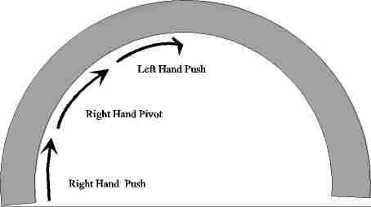
Right Hand Push This cut engages the operator with the bowl and establishes a shoulder to support the bevel and cuts down the side of the bowl.

The bowl gouge is held at a 45 degree angle behind the lathe bed with the flute positioned to face horizontally away from the operator. The operator’s right hand is clamped to the tool in an extreme clockwise rotation with the wrist in a vertical position. The left hand is stationary holding the tool in position.

The edge of the gouge is place against the bowl interior and the right hand pushed into the bowl. The edge catches a small shoulder and the cut proceed downward. When the tool cannot proceed further the operator moves to the second part of the cut

Right Hand Pivot This transitions from the wall (vertical) cut to the bottom cut around the corner and into the bottom cut

Without releasing the initial grip, the right hand pulls forward to a position parallel with the ways of the lathe; at the same time the wrist rotates into a more natural and comfortable forward position. The left hand remains stationary. The tool has now rotated approximately 45° with the flute facing about 2:00 o’clock.

What happens inside the bowl is the tool rotates to a 45 degree angle relative to the wood fibers while pivoting around the inside corner.

Left Hand Push The right hand remains stationary parallel with the ways and the left hand pushes the tool away from the operator.

During this portion of the cut the tool moves horizontally across the bottom of the bowl in a relatively flat cut.

The flute is still facing 45 degrees to the wood fibers.

Although this cut is easy it can also be dangerous if the tool is over rotated. The exposed cutting edge becomes too open and engages along it full length and bites in very deeply becoming a catch.

Gouges – Deep Fluted
(The bowl gouge)

The deep fluted gouge is easily distinguished by longer handle and blade as well as the deeper, more massive flute. This allows the tool to be used farther over the tool rest than the shallower spindle gouge – ideal for turning bowls as well as other items.
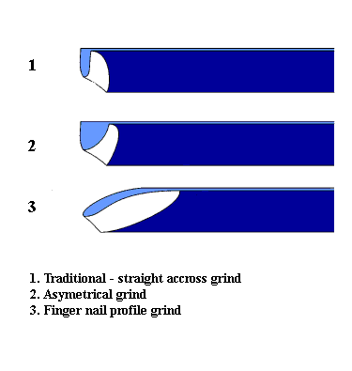
Out of the box the tool may be ground with a traditional-straight across configuration favored by many English and European turners.

In the U. S. the fingernail profile is preferred for its greater flexibility allowing the tool to do pull cuts and shear scraping.

The fingernail profile is also referred to by many names such as Ellsworth, O’Donnell, and Irish grinds.

The length of the side grind, whether straight or radiused and the bevel and side angles are all a matter of personal preference.

Several turners use a combination grind – straight on the right side to allow shear cutting on bowl exteriors and pulled back slightly on the left side to accommodate the turning bowl interiors.

When you buy a new tool don’t assume these new tools are usable until you sharpen it – the shape is normally for presentation only and not sharp.

The exact bevel angle and the length of the side grind are, to say the least, open to active debate. The bluntness of the bevel should be a function of the depth of the bowl you are turning in order to keep the bevel in contact with the interior surface all the way to the bottom. The deeper the bowl - the blunter the tip bevel angle.

Bowl Scrapers

Scrapers are a real work horse tool. They are used to:
- Finish cutting bowl interiors where the gouge become difficult to use
- Complete surfacing prior to sanding
- Make minor shape corrections to a project
- Do the primary cutting in hard, dense materials

Most wood turning scrapers are ground at about 10-15 degrees. The burr can be left or removed depending on your intensions – for soft wood the burr is retained. For bowl interior cuts we prefer the biggest, thickest scraper that will fit into the project as the mass dampens vibration and stabilizes the tool.

Bowl scraper come in many sizes and shapes to allow the shape to conform to the interior shape of the bowl being completed.

With few exceptions scrapers should be used with the handle raised above center line and the blade trailing to centerline to reduce catches – this usually requires raising the tool rest. Rotate the tool rest so that the tool while resting will be slightly skewed over to shear. Holding a scraper on edge is asking for it to be slammed down onto the tool rest with your finger in between.

Turning Your First Bowl

Bowl turning is more dangerous than turning spindles between centers. The possibility of injury is increased. Therefore a full face shield should be worn at all times. Lathe speed should be carefully monitored to assure that a safe operating speed is not exceeded. If the lathe vibrates or moves the speed is too great – reduce it until the wood is brought into balance.

It is a good practice to always start a new bowl protect at 500 RPM until the blank is properly rounded and brought into balance

Activity

Prepare and mount the blank

- It is desirable to create a roughly round shape on the band saw or by hand to allow the blank to run as smoothly as possible when mounted on the lathe.

- Next find the exact center of the trimmed bowl blank and mark it on both sides. On the face side center and mount the lathe’s faceplate with square drive or machine screws. Assure that the faceplate is flat and securely attached to the blank.

- Set the lathe speed to 500 RPM, and mount the face plate/blank securely on the lathe.

- Bring up the tailstock to support the blank until balance is achieved. (The tailstock should always be used for additional support whenever possible.

Turn an exterior rough shape

- Using your deep fluted gouge, turn a pleasing bowl shape beginning at the tail stock end and working toward the headstock. Remember that the flute of the bowl gouge always points in the direction of your cut: tailstock toward headstock. As the balance of the bowl improves, the speed of the lathe can be increased in steps. Remember to use the Rule of 45”s.

- Complete rough turning the exterior shape from base to rim or tailstock end toward the headstock end. When the tool is in position against your body, you will have to move your body in a circular motion transferring your weight from the right foot to the left foot during each cut. If the cut exceeds your reach, stop the cut, reposition your body, then resume the cut from where you left off.

- Turn a tenon on the tailstock side of the rough shaped bowl blank. This dimension of the tenon should be sufficiently large to support the mass of the bowl when reversed into the chuck for hollowing in the following steps. The shape of the tenon must closely match the shape of the chuck jaws being used.

Large bowls require larger tenons and should optimally utilize larger chuck jaws also.

When cutting the tenon remember that all tenons require a flat onto which the chuck jaws will rest providing support for the blank. The length of tenon should be slightly shorter than the depth of the chuck’s jaws so that it rests on the top of the jaws not on the bottom.

- After cutting the tenon, define the bowl’s foot and reshape the exterior to account for the wood lost in creating the tenon and defining the bowl’s foot.

- Remove the bowl blank and faceplate from the lathe and unscrew the faceplate. Mount the four-jaw scroll chuck on the lathe and insert the rough shaped bowl.

- Bring up the tailstock for support, clean up the exterior shape if necessary, sand the exterior to final grit.

Turn the bowl interior using the three part bowl cut

- Starting in the center turn a small bowl shape and work outward and downward until the wall thickness of about 1” is established. The wall thickness should be measured with bowl calipers to assure the constant wall thickness throughout. Be cautious and not allow the center to get thinner than the same wall thickness.

- Begin to work the wall thickness to the final dimension in 1” increments. Work down 1” only checking your measurements as you go. Smooth the final surface. During the first one inch assure that the bowl’s rim is completed since you can’t easily go back to it later.

- Move down another inch, turn the wall to the same thickness and blend the two surfaces together. Always assure that the walls are of a uniform thickness using calipers to measure frequently as you go.

- When you get to the bottom be sure that the bottom curve of the bowl is shallower than the thickness of the walls to allow shaping of the foot at the next step.

- Sand the interior to final and add finish.

Using a bowl scraper

Many times the bowl gouge cannot complete the interior cuts near the bowl bottom center without lifting it from the bevel support. You will get an “unsupported cut” which is very difficult to control and may lead to catches! Here we could use a heavy duty interior bowl scraper to complete the cut.

Scrapers should be held with the handle well above the cutting edge and the edge positioned at the center line of the bowl. Cuts are best done on the pull stroke as they are less aggressive than pushing the scraper into the bowl.

Finishing the foot

- Remove the bowl from your chuck and prepare a jam chuck by turning a small piece of soft wood round and adding a tenon. Insert its tenon into your chuck and tighten.

- True the edge and face of the jam chuck, slightly coving in the face. This step is important every time the jam chuck is reused so that the bowl is well centered when placed on it.

- Place a piece of rubber, sandpaper or other protective material between the bowl and the jam chuck, place the bowl over the jam chuck, and bring up the tail stock live center for support. Tighten the tailstock into the initial spur drive hole remaining from the first step. This centers the bowl on the jam chuck.

- Turn away the majority of the tenon shaping the bowl foot as you do so. Retain a small portion of the tenon for support from the tailstock.

- Remove the completed bowl from the lathe and carve away the nub of wood from the tailstock support using a chisel or carving tool to cut away the remaining tenon. Sand the carved area and add finish.

